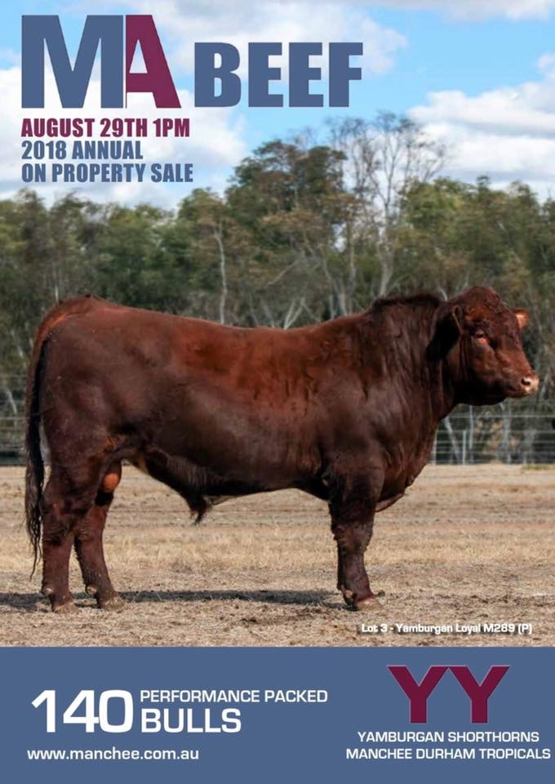

Manchee Ag will be offering 140 lots comprising of;

88 rising 2 year old Shorthorn bulls

22 yearling Shorthorn bulls

30 rising 2 year old Durham Tropical bulls.

All bulls will be tested for HOMOZYGOUS Polledness with results available on sale day.

The catalogue is available here: <https://manchee.com.au/2018-bull-sale-information/>

The sale will be integrated with AuctionsPlus, with the option to watch a live stream of the sale.